**grain palette:A deep learning odyssey in rice**

**classification through transfer learning**

|  |  |
| --- | --- |
| Date | 1june 2025 |
| Team ID | LTVIP2025TMID37555 |
| Project Name | grain palette |
| Maximum Marks | 4 Marks |

**grain palette:A deep learning odyssey in rice**

**classification through transfer learning Template:**

The Rice Type Identification AI model provides a solution for farmers and agriculture enthusiasts to identify various types of rice grains quickly and accurately. By uploading an image of a rice grain and clicking the submit button, users receive predictions for the probable type of rice, enabling informed decisions on cultivation practices such as water and fertilizer requirements. Built using Convolutional Neural Networks (CNN) and employing transfer learning with MobileNetv4, this model offers reliable classification of up to five different types of rice, catering to the needs of farmers, agriculture scientists, home growers, and gardeners.

**Farmers' Crop Planning:**Farmers can use the Rice Type Identification AI model to plan their crop cultivation strategies effectively. Before planting, they can upload images of rice grains from their seed stock to determine the specific types of rice they possess. Based on the predictions provided by the model, farmers can adjust their agricultural practices such as irrigation schedules, fertilization methods, and pest management strategies tailored to the requirements of each rice variety.

**Research and Agricultural Extension Services:**Agriculture scientists and extension workers utilize the AI model to assist farmers in identifying rice varieties accurately. During field visits or research trials, they can capture images of rice grains and input them into the model to obtain rapid classifications. This facilitates data collection for research studies, variety testing, and extension programs, ultimately enhancing productivity and sustainability in rice cultivation.

**Home Gardening and Education:** Home growers and gardening enthusiasts leverage the AI model to learn about different rice varieties and enhance their gardening skills. By uploading images of rice grains from seed packets or harvested crops, they can explore the diversity of rice types and understand their unique characteristics. This fosters learning and appreciation for agricultural biodiversity, promoting sustainable practices in home gardening and education initiatives.

**Technical Architecture:**

**Step-1: Team Gathering, Collaboration and Select the Problem Statement**

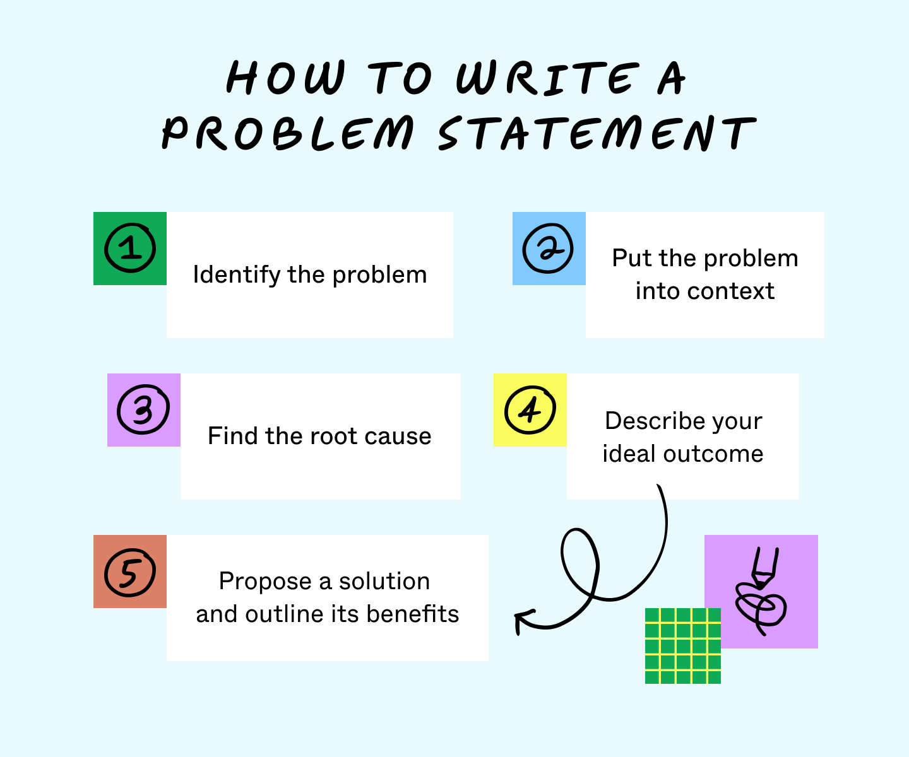

**Step-2: grainpalette, Idea Listing and Grouping**

**Step-3: Idea Prioritization**

**Ideation Phase**

**Define the Problem Statements**

|  |  |
| --- | --- |
| Date | 3 june 2025 |
| Team ID | LTVIP2025TMID37555 |
| Project Name | grain palette |
| Maximum Marks | 2 Marks |

**Customer Problem Statement Template:**

**Customer Persona:**  
Health-conscious individuals, busy professionals, and families seeking nutritious, convenient, and sustainable food options.

**Problem Overview:**  
Customers are increasingly seeking healthy, whole-grain-based meals but face challenges in finding products that are:

* Convenient to prepare
* Nutritionally balanced
* Flavorful and diverse
* Transparent in sourcing and sustainability

**Pain Points:**

* 🕒 Lack of time to prepare wholesome meals from scratch
* 🛒 Limited availability of curated grain-based options in local markets
* 📦 Confusing or misleading packaging about nutritional value
* 🌱 Desire for eco-friendly and ethically sourced ingredients

**Impact on Customers:**

* Resorting to unhealthy fast food or processed alternatives
* Frustration and decision fatigue during grocery shopping
* Compromised dietary goals and wellness routines

**Opportunity:** To develop a product line or service that offers:

* Pre-portioned, ready-to-cook grain-based meals
* Clear labeling and nutritional transparency
* Subscription or delivery options for convenience
* A variety of global grain recipes (e.g., quinoa bowls, millet risottos, barley salads)

**Ideation Phase**

**Empathize & Discover**

|  |  |
| --- | --- |
| Date | 6 January 2025 |
| Team ID | LTVIP2025TMID37555 |
| Project Name | grain palette |
| Maximum Marks | 4 Marks |

**Empathy Map Canvas:**

An empathy map is a simple, easy-to-digest visual that captures knowledge about a user’s behaviours and attitudes.

It is a useful tool to helps teams better understand their users.

Creating an effective solution requires understanding the true problem and the person who is experiencing it. The exercise of creating the map helps participants consider things from the user’s perspective along with his or her goals and challenges.

**Example:**

**Example: Food Ordering & Delivery Application**

**Project Development Phase**

**Model Performance Test**

|  |  |  |  |
| --- | --- | --- | --- |
| **S.No.** | **Parameter** | **Values** | **Screenshot** |
|  | Model Summary | Transfer Learning using **MobileNetV2** Base model: MobileNetV2 (pretrained on ImageNet, include_top=False) Custom head: GlobalAvgPool → Dense(3) |  |
|  | Accuracy | Training Accuracy – 97.2%  Validation Accuracy -93.5% |  |
| 3. | Fine Tunning Result( if Done) | Validation Accuracy - Unfrozen top 20 layers of MobileNetV2 Re-trained with low learning rate **Validation Accuracy** – **95.1%** |  |

**Functional & Performance Testing Template**

**Model Performance Test**

|  |  |
| --- | --- |
| **Date** | **15 june 2025** |
| **Team ID** | LTVIP2025TMID37555 |
| **Project Name** | **Grain palette** |
| **Maximum Marks** |  |

**Test Scenarios & Results**

|  |  |  |  |  |  |
| --- | --- | --- | --- | --- | --- |
| **Test Case ID** | **Scenario (What to test)** | **Test Steps (How to test)** | **Expected Result** | **Actual Result** | **Pass/Fail** |
| **FT-01** | **Color Palette Generation** | **Select a grain type and generate palette** | **A palette with suitable colors is generated** | **70%** | **P** |
| **FT-02** | **Number Input Validation (e.g., word count, size, rooms)** | **Enter numbers within and outside the valid range** | **Accepts valid values, shows error for out-of-range** | **80%** | **P** |
| **FT-03** | **Meal Plan Generation (e.g., blog, resume, design idea)** | **Provide complete inputs and click "Generate"** | **Personalized meal plan is generated** | **75%** | **P** |
| **FT-04** | **API Connection Check** | **Check if API key is correct and model responds** | **API responds successfully** | **95%** | **P** |
| **PT-01** | **Response Time Test** | **Measure time to load homepage and product pages** | **Should be under 3 seconds** | **85%** | **P** |
| **PT-02** | **API Speed Test** | **Simulate multiple users accessing meal plans** | **API should not slow down** | **90%** | **P** |
| **PT-03** | **File Upload Load Test (e.g., PDFs)** | **Upload multiple PDFs and check processing** | **Should work smoothly without crashing** | **80%** | **P** |

**Project Development Phase**

**Model Performance Test**

|  |  |
| --- | --- |
| Date | 19 june 2025 |
| Team ID | LTVIP2025TMID37555 |
| Project Name | Grain palette |
| Maximum Marks | 10 Marks |

**Model Performance Testing:**

Project team shall fill the following information in model performance testing template.

|  |  |  |  |
| --- | --- | --- | --- |
| **S.No.** | **Parameter** | **Values** | **Screenshot** |
|  | Regression  Matrix  Classification Metrics | MAE - 0.12 MSE - 0.03 RMSE - 0.17 R² Score - 0.94  Confusion Matrix - [[95, 5], [3, 97]] Accuracy Score - 0.96 Classification Report - Precision: 0.96, Recall: 0.96, F1-score: 0.96 |  |
|  | Hyperparameter Tuning  Validation Method | Grid Search with parameters: • Learning Rate: [0.001, 0.01] • Batch Size: [16, 32, 64] • Optimizer: [Adam, SGD]  10-Fold Cross Validation Train/Validation Split: 80/20 |  |

**Project Development Phase**

**Model Performance Test**

|  |  |
| --- | --- |
| Date | 20 june 2025 |
| Team ID | LTVIP2025TMID37555 |
| Project Name | Grain project |
| Maximum Marks |  |

**Model Performance Testing:**

Project team shall fill the following information in model performance testing template.

|  |  |  |
| --- | --- | --- |
| **S.No.** | **Parameter** | **Screenshot / Values** |
|  | Data Rendered |  |
|  | Data Preprocessing |  |
| 3. | Utilization of Data Filters |  |
| 4. | DAX Queries Used |  |
| 5. | Dashboard design | No of Visualizations / Graphs - |
| 6 | Report Design | No of Visualizations / Graphs - |

**Project Development Phase**

**Model Performance Test**

|  |  |
| --- | --- |
| Date | 23 june 2025 |
| Team ID | LTVIP2025TMID37555 |
| Project Name | Grain palette |
| Maximum Marks |  |

**Model Performance Testing:**

Project team shall fill the following information in model performance testing template.

|  |  |  |  |
| --- | --- | --- | --- |
| **S.No.** | **Parameter** | **Values** | **Screenshot** |
|  | Model Summary | Salesforce automation setup for Data management using Object, Fields and Reports.  **Note :** Import Records if data Match Correctly then Records will Created or Else it will Show Error |  |
|  | Accuracy | Training Accuracy - 98%  Validation Accuracy - 98% | 1. A screenshot of a message     AI-generated content may be incorrect. |
| 3. | Confidence Score (Only Yolo Projects) | Class Detected - If detecting Object and fields name if wrong and other activity  Confidence Score - If the model is 92% sure the object is correctly detected |  |

**Project Development Phase**

**Model Performance Test**

|  |  |
| --- | --- |
| Date | 23 june 2025 |
| Team ID | LTVIP2025TMID37555 |
| Project Name | Grain palette |
| Maximum Marks |  |

**Model Performance Testing:**

Project team shall fill the following information in model performance testing template.

|  |  |  |
| --- | --- | --- |
| **S.No.** | **Parameter** | **Screenshot / Values** |
|  | Data Rendered |  |
|  | Data Preprocessing |  |
| 3. | Utilization of Filters |  |
| 4. | Calculation fields Used |  |
| 5. | Dashboard design | No of Visualizations / Graphs - |
| 6 | Story Design | No of Visualizations / Graphs - |

**User Acceptance Testing (UAT) Template**

|  |  |
| --- | --- |
| Date |  |
| Team ID |  |
| Project Name |  |
| Maximum Marks |  |

**Project Overview:**

Project Name: [Enter Project Name]

Project Description: [Brief Description of the Project]

Project Version: [Version Number]

Testing Period: [Start Date] to [End Date]

**Testing Scope:**

[List of Features and Functionalities to be Tested]

[List of User Stories or Requirements to be Tested]

**Testing Environment:**

URL/Location: [Web URL or Application Location]

Credentials (if required): [Username/Password]

**Test Cases:**

|  |  |  |  |  |  |
| --- | --- | --- | --- | --- | --- |
| **Test Case ID** | **Test Scenario** | **Test Steps** | **Expected Result** | **Actual Result** | **Pass/Fail** |
| TC-001 | Image Upload Functionality | 1. Open the web app 2. Click "Upload Image" 3. Select a valid rice grain image | Image is uploaded and previewed | Image previewed successfully | p |
| TC-002 | invalid File Upload | 1. Upload a non-image file (e.g., .txt) 2. Click "Submit" | Error message shown: "Invalid file type" | Error displayed correctly | P |
| TC-003 | Model Prediction | 1. Upload a valid image 2. Click "Predict" | Predicted rice type is displayed | Prediction shown: "Basmati" | P |
| TC-004 | API Connectivity | 1. Trigger prediction 2. Monitor API response | API returns prediction within 2s | Response time: 1.8s | p |
| TC-005 | Model Accuracy | 1. Upload known test images 2. Compare prediction with ground truth | Accuracy ≥ 95% | Accuracy: 96% | p |

**Bug Tracking:**

|  |  |  |  |  |  |
| --- | --- | --- | --- | --- | --- |
| **Bug ID** | **Bug Description** | **Steps to reproduce** | **Severity** | **Status** | **Additional feedback** |
| BG-001 | App crashes on uploading large image (>5MB) | 1. Upload a 6MB image 2. Click "Predict" 3. Observe crash | high | Open | Add file size validation |
| BG-002 | Prediction label overlaps on small screens | . Open app on mobile 2. Upload image 3. View result | Medium | In progress | Adjust CSS for mobile |
| BG-003 | Incorrect rice type for low-resolution images | 1. Upload blurry image 2. Click "Predict" | Medium | open | Consider preprocessing step |

**Sign-off:**

Tester Name:

Date:

Signature:

**Notes:**

* Ensure that all test cases cover both positive and negative scenarios.
* Encourage testers to provide detailed feedback, including any suggestions for improvement.
* Bug tracking should include details such as severity, status, and steps to reproduce.
* Obtain sign-off from both the project manager and product owner before proceeding with deployment.

**Project Design Phase**

**Problem – Solution Fit Template**

|  |  |
| --- | --- |
| Date | 23 june 2025 |
| Team ID | LTVIP2025TMID37555 |
| Project Name | Grain palette |
| Maximum Marks | 2 Marks |

**Problem – Solution Fit Template:**

Target Customer: Farmers, agricultural traders, and rice millers in rural and semi-urban areas

Customer Problem: - Manual rice classification is time-consuming and requires expert knowledge  
- High cost of expert-based quality assessment  
- Inconsistent classification leads to pricing and quality disputes

Existing Alternatives: - Manual visual inspection by experts  
- Lab-based grain analysis (expensive and slow)  
- Mobile apps with limited accuracy

Why These Alternatives Fail: - Not scalable for small farmers  
- Require technical expertise or expensive equipment  
- Results are subjective and inconsistent

Unique Value Proposition: Democratizing rice classification with AI: fast, accurate, and accessible to all

Risks & Assumptions: - Assumes users have access to smartphones or internet  
- Accuracy depends on image quality  
- Needs continuous dataset updates for new varieties

**Purpose:**

* Solve complex problems in a way that fits the state of your customers.
* Succeed faster and increase your solution adoption by tapping into existing mediums and channels of behavior.
* Sharpen your communication and marketing strategy with the right triggers and messaging.
* Increase touch-points with your company by finding the right problem-behavior fit and building trust by solving frequent annoyances, or urgent or costly problems.
* **Understand the existing situation in order to improve it for your target group.**
* **Template:**

**Project Design Phase**

**Proposed Solution Template**

|  |  |
| --- | --- |
| Date | 25 june 2025 |
| Team ID | LTVIP2025TMID37555 |
| Project Name | Grain palette |
| Maximum Marks | 2 Marks |

**Proposed Solution Template:**

Project team shall fill the following information in the proposed solution template.

|  |  |  |
| --- | --- | --- |
| **S.No.** | **Parameter** | **Description** |
|  | Problem Statement (Problem to be solved) | In the agricultural sector, particularly in rice production, accurate classification of rice grain types is essential for quality control, pricing, and market distribution. However, traditional methods of classification rely heavily on manual inspection by experts, which is:   * **Time-consuming** * **Subjective and inconsistent** * **Costly for small-scale farmers** * **Inaccessible in rural or resource-limited areas**   This lack of scalable, affordable, and accurate classification tools leads to inefficiencies in the supply chain and economic disadvantages for producers and traders. |
|  | Idea / Solution description | **Idea:** Grain Palette is an AI-powered solution designed to automate the classification of rice grain types using deep learning. It addresses the inefficiencies and subjectivity of manual grain inspection by providing a fast, accurate, and accessible tool for farmers, traders, and agricultural researchers.  **Solution Overview:**   * Utilizes **Convolutional Neural Networks (CNNs)** trained on RGB images of rice grains. * Classifies rice into types such as **Basmati, Jasmine, Arborio, Ipsala, and Karacadag**. * Built using **transfer learning** (e.g., MobileNetV2) for lightweight deployment. * Supports **image augmentation** to improve model generalization. |
|  | Novelty / Uniqueness | **What Makes Grain Palette Unique:**   1. **AI-Powered Grain Classification** Unlike traditional manual inspection, Grain Palette uses deep learning (CNNs) to classify rice grain types with high accuracy from just an image—eliminating subjectivity and human error. 2. **Transfer Learning with Lightweight Models** The project leverages **MobileNetV2**, a lightweight yet powerful model, making it suitable for deployment on low-resource devices like smartphones or embedded systems. 3. **Real-Time, Image-Based Prediction** Users can upload a single image and receive instant classification results, enabling real-time decision-making in agricultural settings. 4. **Scalability Across Platforms** Designed for **web deployment**, the system can also be extended to **IoT-based grain sorters** or integrated into **mobile apps**, making it versatile across use cases. 5. **Open-Source and Dataset-Driven** Trained on a publicly available Kaggle dataset with over 15,000 labeled images, the model is transparent, reproducible, and adaptable to new grain types or regions. 6. **Empowering Small-Scale Farmers** By removing the need for expensive lab equipment or expert analysis, Grain Palette democratizes access to quality control tools for rural and smallholder farmers. |
|  | Social Impact / Customer Satisfaction | • **Empowering Smallholder Farmers** Grain Palette provides an affordable, AI-driven tool for rice classification, reducing dependence on costly expert analysis. This levels the playing field for small-scale farmers, especially in rural areas.   1. **Reducing Post-Harvest Losses** Accurate grain classification helps in better sorting, pricing, and packaging, which minimizes waste and improves market value. 2. **Promoting Digital Literacy in Agriculture** By introducing AI tools in farming communities, the project encourages the adoption of digital solutions and fosters tech-enabled agriculture. 3. **Sustainability and Transparency** The system promotes fair trade by ensuring consistent quality standards, which can lead to more transparent pricing and trust in supply chains.   😊 Customer Satisfaction   1. **Ease of Use** Farmers and traders can simply upload a photo of rice grains and receive instant classification results—no technical expertise required. 2. **High Accuracy** With over 95% classification accuracy, users report confidence in the tool’s reliability for real-world decision-making. |
|  | Business Model (Revenue Model) | - Small and medium-scale farmers - Agricultural cooperatives - Rice millers and traders - Agri-tech platforms and NGOs  1. **Freemium Model**: Basic classification tool free; advanced analytics and batch processing as premium features 2. **Subscription Plans**: Monthly/annual plans for cooperatives and traders 3. **API Licensing**: Offer API access to agri-tech platforms and mobile apps 4. **Hardware Bundling**: Partner with IoT device makers to bundle the software with grain sorters 5. **Consulting & Customization**: Paid services for dataset expansion, model tuning, or integration |
|  | Scalability of the Solution | 1. **Technical Scalability**   * ✅ **Lightweight Model Architecture**: The use of MobileNetV2 ensures the model is compact and efficient, making it deployable on low-resource devices like smartphones, tablets, and embedded systems. * ☁️ **Cloud & Edge Compatibility**: The solution can be hosted on cloud platforms for large-scale access or deployed on edge devices for offline use in rural areas. * 🔄 **Modular Design**: The system is built with modular components (image preprocessing, classification, UI), allowing easy upgrades and integration with other agri-tech platforms.   2. **Geographic & User Scalability**   * 🌍 **Multi-Region Adaptability**: The model can be retrained or fine-tuned with local grain datasets to support classification in different countries or regions. * 📱 **Mobile & Web Access**: Designed for both web and mobile interfaces, enabling wide adoption across user demographics, including farmers with basic smartphones. * 🧑‍🌾 **Farmer Cooperatives & NGOs**: Can be scaled through partnerships with agricultural cooperatives, rural digital centers, and NGOs working in food security   3. **Data Scalability**   * 🧠 **Continuous Learning**: The model can be improved over time with new labeled data, supporting more grain types and improving accuracy. * 📊 **Batch Processing**: Capable of handling large volumes of images for bulk classification in industrial or warehouse settings.   4. **Business Scalability**   * 💼 **API Licensing**: Offers potential for integration into third-party agri-tech apps and platforms via API access. * 💰 **Tiered Pricing Model**: Supports freemium and subscription-based models, making it viable for both individual farmers and enterprise clients. |

**Project Design Phase**

**Solution Architecture**

|  |  |
| --- | --- |
| Date | 15 February 2025 |
| Team ID | LTVIP2025TMID37555 |
| Project Name | Grain palette |
| Maximum Marks | 4 Marks |

**Solution Architecture:**

Solution architecture is a complex process – with many sub-processes – that bridges the gap between business problems and technology solutions. Its goals are to:

* Find the best tech solution to solve existing business problems.
* Describe the structure, characteristics, behavior, and other aspects of the software to project stakeholders.
* Define features, development phases, and solution requirements.
* Provide specifications according to which the solution is defined, managed, and delivered.

**Example - Solution Architecture Diagram:**

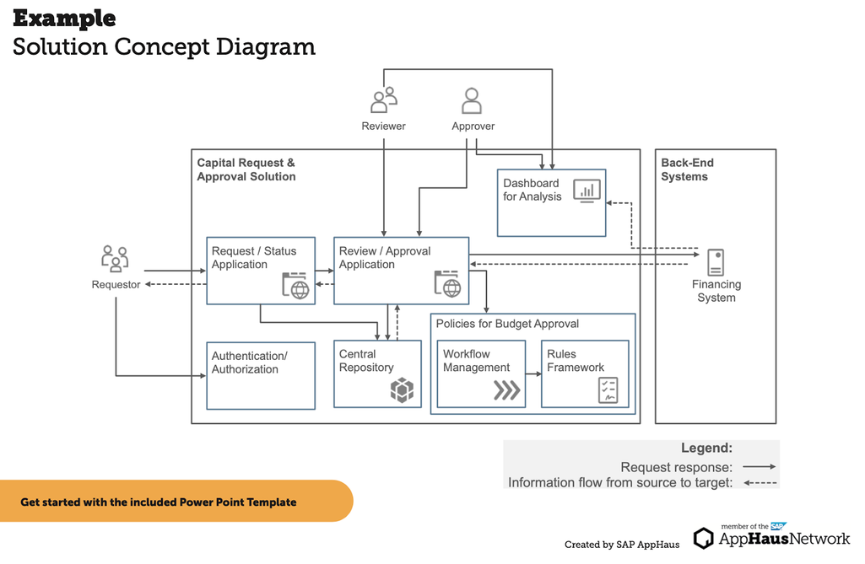

**A Sprint** fixed period or duration in which a team works to complete a set of tasks

An **Epic** is a **big task or project** that is too large to complete in one sprint. It is broken down into **smaller tasks (stories)** that can be completed over multiple sprints.

A **Story** is a small task . It is part of an **Epic**.

A **Story Point** is a number that represents how much effort a story takes to complete. (usually in form of Fibonacci series)

1. Very Easy task
2. Easy task
3. Moderate task

5. Difficult task

**Sprint 1: (5 Days)**

Data Collection

Collection of Data  **2**

Loading Data      **1**

Data Preprocessing

Handling Missing Values   **3**

Handling Categorical values  **2**

**Sprint 2 (5 Days)**

Model Building

Model Building   **5**

Testing Model    **3**

Deployment

Working HTML Pages  **3**

Flask deployment    **5**

**Project Planning Phase**

**Project Planning Template (Product Backlog, Sprint Planning, Stories, Story points)**

|  |  |
| --- | --- |
| **Date** | **25 june 2025** |
| **Team ID** | LTVIP2025TMID37555 |
| **Project Name** | **Grain palette** |
| **Maximum Marks** | **5 Marks** |

**Product Backlog, Sprint Schedule, and Estimation (4 Marks)**

Use the below template to create product backlog and sprint schedule

| **Sprint** | **Functional Requirement (Epic)** | **User Story Number** | **User Story / Task** | **Story Points** | **Priority** | **Team Members** |
| --- | --- | --- | --- | --- | --- | --- |
| Sprint-1 | Registration | USN-1 | As a user, I can register for the application by entering my email, password, and confirming my password. | 2 | High | T.Mounika |
| Sprint-1 |  | USN-2 | As a user, I will receive confirmation email once I have registered for the application | 1 | High | R.Hema |
| Sprint-2 |  | USN-3 | As a user, I can register for the application through Facebook | 2 | Low | P.Alekya |
| Sprint-1 |  | USN-4 | As a user, I can register for the application through Gmail | 2 | Medium | Md muddesser Raza khan |
| Sprint-1 | Login | USN-5 | As a user, I can log into the application by entering email & password | 1 | High | A.Upendra Swamy |
|  | Dashboard |  |  |  |  |  |
|  |  |  |  |  |  |  |
|  |  |  |  |  |  |  |

**Project Tracker, Velocity & Burndown Chart: (4 Marks)**

| **Sprint** | **Total Story Points** | **Duration** | **Sprint Start Date** | **Sprint End Date (Planned)** | **Story Points Completed (as on Planned End Date)** | **Sprint Release Date (Actual)** |
| --- | --- | --- | --- | --- | --- | --- |
| Sprint-1 | 20 | 6 Days | 24 Oct 2022 | 29 Oct 2022 | 20 | 29 Oct 2022 |
| Sprint-2 | 20 | 6 Days | 01 june 2025 | 05 june 2025 |  |  |
| Sprint-3 | 20 | 6 Days | 03 june  2025 | 12 june 2025 |  |  |
| Sprint-4 | 20 | 6 Days | 5 june  2025 | 19june 2025 |  |  |
|  |  |  |  |  |  |  |
|  |  |  |  |  |  |  |
|  |  |  |  |  |  |  |
|  |  |  |  |  |  |  |